Macro – Homework 2

Multiple Choice
Identify the choice that best completes the statement or answers the question.

____ 1. Which of the following is correct?
a. | Some bonds have terms as short as a few months.
b. | Because they are so risky, junk bonds pay a low rate of interest.
c. | Corporations buy bonds to raise funds.
d. | All of the above are correct.

____ 2. Consider the expressions T - G and Y - T - C. Which of the following statements is correct?
a. | Each one of these is equal to national saving.
b. | Each one of these is equal to public saving.
c. | The first of these is private saving; the second one is public saving.
d. | The first of these is public saving; the second one is private saving.

____ 3. Suppose that in a closed economy GDP is equal to 11,000, taxes are equal to 2,500, consumption equals 7,000, and government purchases equal 3,000. What are private saving and public saving?
a. | 1,500 and -500, respectively
b. | 1,500 and 500, respectively
c. | 1,000 and -500, respectively
d. | 1,000 and 500, respectively

____ 4. The source of the supply of loanable funds
a. | is saving and the source of demand for loanable funds is investment.
b. | is investment and the source of demand for loanable funds is saving.
c. | and the demand for loanable funds is saving.
d. | and the demand for loanable funds is investment.

____ 5. If the demand for loanable funds shifts to the right, then the equilibrium interest rate
a. | and quantity of loanable funds rise.
b. | and quantity of loanable funds fall.
c. | rises and the quantity of loanable funds falls.
d. | falls and the quantity of loanable funds rises.

____ 6. If the inflation rate is 2 percent and the real interest rate is 3 percent, then the nominal interest rate is
a. | 5 percent.
b. | 1 percent.
c. | 1.5 percent
d. | 0.67 percent.

____ 7. If the interest rate is 7.5 percent, then what is the present value of $4,000 to be received in 6 years?
a. | $2,420.68
b. | $2,591.85
c. | $2,996.33
d. | $3,040.63

____ 8. Imagine that someone offers you $100 today or $200 in 10 years. You would prefer to take the $100 today if the interest rate is
a. | 4 percent.
b. | 5 percent.
c. | 6 percent.
d. | None of the above are correct.

____ 9. Which of the following is adverse selection?
a. | the risk associated with selecting stocks in only a few specific companies
b. | the risk that a person will become overconfident in his ability to select stocks
c. | a high-risk person being more likely to apply for insurance
d. | after obtaining insurance a person having less incentive to be careful

____ 10. When you rent a car, you might treat it with less care than you would if it were your own. This is an example of
a. | market risk.
b. | moral hazard.
c. | adverse selection.
d. | risk aversion.

____ 11. If the efficient markets hypothesis is correct, then
a. | the number of shares of stock offered for sale exceeds the number of shares of stock that people want to buy.
b. | the stock market is informationally efficient.
c. | stock prices never follow a random walk.
d. | All of the above are correct.

____ 12. Dividends
a. | are the rates of return on mutual funds.
b. | are cash payments that companies make to shareholders.
c. | are the difference between the price and present value per share of a stock.
d. | are the rates of return on a company’s capital stock.

____ 13. The natural rate of unemployment is the
a. | unemployment rate that would prevail with zero inflation.
b. | rate associated with the highest possible level of GDP.
c. | difference between the long-run and short-run unemployment rates.
d. | amount of unemployment that the economy normally experiences.

____ 14. Zeeman is a college student who is not working or looking for a job. The Bureau of Labor Statistics counts Zeeman as
a. | unemployed and in the labor force.
b. | unemployed, but not in the labor force.
c. | in the labor force, but not unemployed.
d. | neither in the labor force nor unemployed.

____ 15. Frictional unemployment is inevitable because
a. | sectoral shifts are always happening.
b. | there is a federal minimum-wage law in the U.S.
c. | some people do not want to be employed.
d. | unions are very popular in the U.S.

____ 16. Collective bargaining refers to
a. | the process by which the government sets exemptions from the minimum wage law.
b. | setting the same wage for all employees to prevent conflict among workers.
c. | firms colluding to set the wages of employees in order to keep them below equilibrium.
d. | the process by which unions and firms agree on the terms of employment.

____ 17. The theory of efficiency wages explains why
a. | setting wages at the equilibrium level may increase unemployment.
b. | it may be in the best interest of firms to offer wages that are above the equilibrium level.
c. | the most efficient way to pay workers is to pay them according to their skills.
d. | it is efficient for firms to set wages at the equilibrium level.

____ 18. When we want to measure and record economic value, we use money as the
a. | liquid asset.
b. | medium of exchange.
c. | unit of account.
d. | store of value.

____ 19. Which list ranks assets from most to least liquid?
a. | currency, fine art, stocks
b. | currency, stocks, fine art
c. | fine art, currency, stocks
d. | fine art, stocks, currency

____ 20. Paper dollars
a. | are commodity money and gold coins are fiat money.
b. | are fiat money and gold coins are commodity money.
c. | and gold coins are both commodity monies.
d. | and gold coins are both fiat monies.

____ 21. Mia puts money into a piggy bank so she can spend it later. What function of money does this illustrate?
a. | store of value
b. | medium of exchange
c. | unit of account
d. | None of the above is correct.

____ 22. The Federal Reserve
a. | is a central bank; it is responsible for conducting the nation’s monetary policy; and it plays a role in regulating banks.
b. | is a central bank; it is responsible for conducing the nation’s monetary policy; but it plays no role in regulating banks.
c. | is not a central bank; it is responsible for conducing the nation’s monetary policy; and it plays a role in regulating banks.
d. | is a central bank; it plays a role in regulating banks; but it is not responsible for conducting the nation’s monetary policy.

____ 23. If the reserve ratio for all banks is 20 percent, then $100 of new reserves can generate
a. | $60 of new money in the economy.
b. | $250 of new money in the economy.
c. | $500 of new money in the economy.
d. | $2,000 of new money in the economy.

____ 24. To increase the money supply, the Fed could
a. | sell government bonds.
b. | decrease the discount rate.
c. | increase the reserve requirement.
d. | None of the above is correct.

____ 25. If velocity = 3.5, the quantity of money = 15,000, and the price level = 1.2, then the real value of output is
a. | 3,571.43.
b. | 4,285.71.
c. | 5,142.86.
d. | 43,750.00.

____ 26. The inflation tax refers to
a. | the revenue a government creates by printing money.
b. | higher inflation which requires more frequent price changes.
c. | the idea that, other things the same, an increase in the tax rate raises the inflation rate.
d. | taxes being indexed for inflation.

Figure 30-1
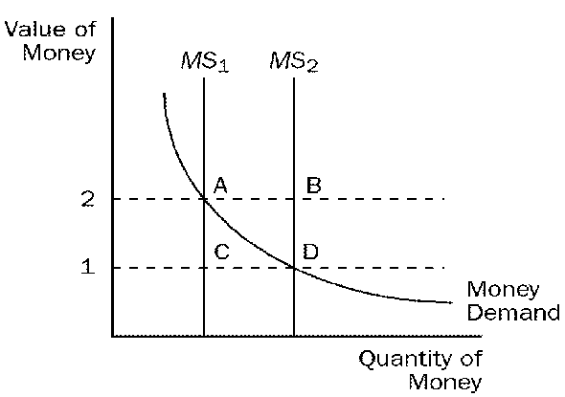

____ 27. Refer to Figure 30-1. When the money supply curve shifts from MS₁ to MS₂,
a. | the demand for goods and services decreases.
b. | the economy's ability to produce goods and services increases.
c. | the equilibrium price level increases.
d. | the equilibrium value of money increases.

____ 28. When inflation rises, people will desire to hold
a. | less money and will go to the bank less frequently.
b. | less money and will go to the bank more frequently.
c. | more money and will go to the bank less frequently.
d. | more money and will go to the bank more frequently.

____ 29. Wealth is redistributed from creditors to debtors when inflation was expected to be
a. | high and it turns out to be high.
b. | low and it turns out to be low.
c. | low and it turns out to be high.
d. | high and it turns out to be low.

