Macro - Homework 1

**Multiple Choice**

*Identify the choice that best completes the statement or answers the question.*

____ 1. College-age athletes who drop out of college to play professional sports

|  |  |
| --- | --- |
| a. | are not rational decision makers. |
| b. | are well aware that their opportunity cost of attending college is very high. |
| c. | are concerned more about present circumstances than their future. |
| d. | underestimate the value of a college education. |

____ 2. The willingness of citizens to pay for a vaccinations does not include the benefit society receives from having vaccinated citizens who cannot transmit an illness to others. This extra benefit society gets from vaccinating its citizens is known as

|  |  |
| --- | --- |
| a. | productivity. |
| b. | an externality. |
| c. | market power. |
| d. | property rights. |

____ 3. What is the most important factor that explains differences in living standards across countries?

|  |  |
| --- | --- |
| a. | the quantity of money |
| b. | the level of unemployment |
| c. | productivity |
| d. | equality |

____ 4. The mainstream view among economists is that

|  |  |
| --- | --- |
| a. | society faces a tradeoff between unemployment and inflation, but only in the short run. |
| b. | society faces a tradeoff between unemployment and inflation, but only in the long run. |
| c. | society faces a tradeoff between unemployment and inflation, both in the short run and in the long run. |
| d. | no tradeoff exists between unemployment and inflation, either in the short run or in the long run. |

***Figure 2-1***

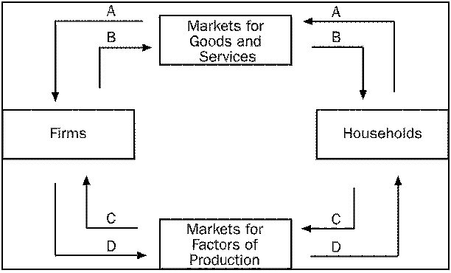

____ 5. **Refer to Figure 2-1.** Enid completes her first week of employment working as a hairdresser at a salon. On Friday of that week, she receives her first paycheck. To which of the arrows does this transaction directly contribute?

|  |  |
| --- | --- |
| a. | B only |
| b. | A and B |
| c. | C only |
| d. | C and D |

____ 6. Any point on a country's production possibilities frontier represents a combination of two goods that an economy

|  |  |
| --- | --- |
| a. | will never be able to produce. |
| b. | can produce using all available resources and technology. |
| c. | can produce using some portion, but not all, of its resources and technology. |
| d. | may be able to produce in the future with more resources and/or superior technology. |

____ 7. A production possibilities frontier shifts outward when

|  |  |
| --- | --- |
| a. | the economy experiences economic growth. |
| b. | the desires of the economy’s citizens change. |
| c. | at least one of the basic principles of economics is violated. |
| d. | opportunity costs are lessened. |

____ 8. Which of the following is an example of a normative, as opposed to positive, statement?

|  |  |
| --- | --- |
| a. | Universal health care would be good for U.S. citizens. |
| b. | An increase in the cigarette tax would cause a decrease in the number of smokers. |
| c. | A decrease in the minimum wage would decrease unemployment. |
| d. | A law requiring the federal government to balance its budget would increase economic growth. |

***Figure 8-5***

Suppose that the government imposes a tax of P3 - P1.



____ 9. **Refer to Figure 8-5**. Tax revenue after the tax is represented by area

|  |  |
| --- | --- |
| a. | B. |
| b. | B+C+D+H. |
| c. | B+D. |
| d. | none of the above. |

____ 10. **Refer to Figure 8-5**. After the tax is levied, producer surplus is represented by area

|  |  |
| --- | --- |
| a. | A. |
| b. | A+B+C. |
| c. | D+H+F. |
| d. | F. |

____ 11. Suppose a tax of $1 per unit is imposed on a good. The more elastic the demand for the good, other things equal,

|  |  |
| --- | --- |
| a. | the larger is the decrease in quantity demanded as a result of the tax. |
| b. | the smaller is the tax burden on buyers relative to the tax burden on sellers. |
| c. | the larger is the deadweight loss of the tax. |
| d. | All of the above are correct. |

____ 12. The Laffer curve relates

|  |  |
| --- | --- |
| a. | the tax rate to tax revenue raised by the tax. |
| b. | the tax rate to the deadweight loss of the tax. |
| c. | the price elasticity of supply to the deadweight loss of the tax. |
| d. | government welfare payments to the birth rate. |

____ 13. When a country allows trade and becomes an exporter of a good,

|  |  |
| --- | --- |
| a. | domestic producers gain and domestic consumers lose. |
| b. | domestic producers lose and domestic consumers gain. |
| c. | domestic producers and domestic consumers both gain. |
| d. | domestic producers and domestic consumers both lose. |

***Figure 9-5***

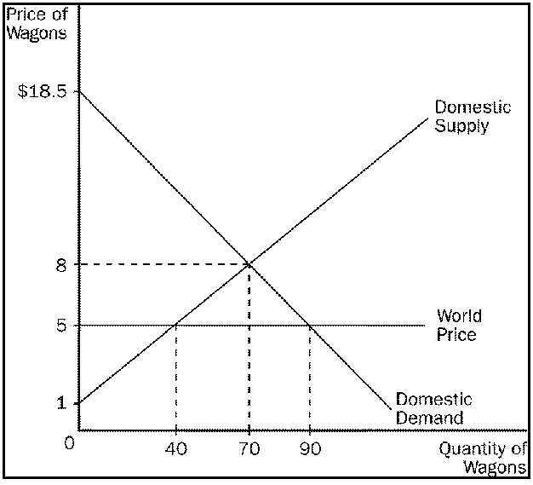

____ 14. **Refer to Figure 9-5**. If this country allows free trade in wagons,

|  |  |
| --- | --- |
| a. | consumers will gain and producers will lose. |
| b. | consumers will lose and producers will gain. |
| c. | both consumers and producers will gain. |
| d. | both consumers and producers will lose. |

***Figure 9-15***

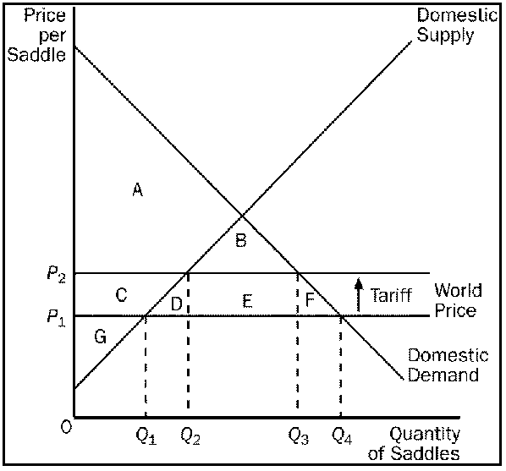

____ 15. **Refer to Figure 9-15**. For the saddle market, area E represents

|  |  |
| --- | --- |
| a. | government’s revenue from the tariff. |
| b. | producer surplus after the tariff becomes effective. |
| c. | the decrease in consumer surplus, relative to the free-trade situation, as a result of the tariff. |
| d. | the decrease in total surplus, relative to the free-trade situation, as a result of the tariff. |

***Figure 9-17***



____ 16. **Refer to Figure 9-17.** What quota amount would be equivalent to the tariff?

|  |  |
| --- | --- |
| a. | 16 but total surplus would be higher under a tariff. |
| b. | 16 but total surplus would be lower under a tariff. |
| c. | 9 but total surplus would be higher under a tariff. |
| d. | 9 but total surplus would be lower under a tariff. |

____ 17. If a state made a previously-illegal activity, such as gambling or prostitution, legal, then, other things equal, GDP

|  |  |
| --- | --- |
| a. | necessarily decreases. |
| b. | necessarily increases. |
| c. | doesn't change because both legal and illegal production are included in GDP. |
| d. | doesn't change because these activities are never included in GDP. |

____ 18. Which of the following items is included in U.S. GDP?

|  |  |
| --- | --- |
| a. | goods produced by foreign citizens working in the United States |
| b. | the difference in the price of the sale of an existing home and its original purchase price |
| c. | known illegal activities |
| d. | None of the above is included in U.S. GDP. |

____ 19. Which of the following values would be included in U.S. GDP for 2006?

|  |  |
| --- | --- |
| a. | the rent that John, an American citizen, would have paid on his home in New York in 2006 had he not owned that home |
| b. | the rent that Sarah, an American citizen, paid on her apartment in San Francisco in 2006 |
| c. | the value of the legal services provided by Carlos, an attorney and a Mexican citizen, who lived in Houston and practiced law there in 2006 |
| d. | All of the above would be included in U.S. GDP for 2006. |

____ 20. Which of the following statements about GDP is correct?

|  |  |
| --- | --- |
| a. | Nominal GDP values production at current prices, whereas real GDP values production at constant prices. |
| b. | Nominal GDP values production at constant prices, whereas real GDP values production at current prices. |
| c. | Nominal GDP values production at market prices, whereas real GDP values production at the cost of the resources used in the production process. |
| d. | Nominal GDP consistently underestimates the value of production, whereas real GDP consistently overestimates the value of production. |

____ 21. Which of the following changes in the price index produces the greatest rate of inflation: 100 to 110, 150 to 165, or 180 to 198?

|  |  |
| --- | --- |
| a. | 100 to 110 |
| b. | 150 to 165 |
| c. | 180 to 198 |
| d. | All of these changes produce the same rate of inflation. |

***Table 24-1***

The table below pertains to Pieway, an economy in which the typical consumer’s basket consists of 10 bushels of peaches and 15 bushels of pecans.

|  |  |  |
| --- | --- | --- |
| Year | Price of  Peaches | Price of  Pecans |
| 2005 | $11 per bushel | $6 per bushel |
| 2006 | $9 per bushel | $10 per bushel |

____ 22. **Refer to Table 24-1**. If 2006 is the base year, then the inflation rate in 2006 was

|  |  |
| --- | --- |
| a. | 16.7 percent. |
| b. | 20 percent. |
| c. | 40 percent. |
| d. | 44.1 percent. |

____ 23. The consumer price index and the GDP deflator are two alternative measures of the overall price level. Which of the following statements about the two measures is correct?

|  |  |
| --- | --- |
| a. | The CPI involves a base year; the GDP deflator does not involve a base year. |
| b. | The CPI can be used to compute the inflation rate; the GDP deflator cannot be used to compute the inflation rate. |
| c. | The CPI reflects the prices of goods and services produced domestically; the GDP deflator reflects the prices of all goods and services bought by consumers. |
| d. | The CPI reflects a fixed basket of goods and services; the GDP deflator reflects current production of goods and services. |

____ 24. In 1970, Professor Plum earned $12,000; in 1980, he earned $24,000; and in 1990, he earned $36,000. If the CPI was 40 in 1970, 70 in 1980, and 130 in 1990, then in real terms, Professor Plum's salary was highest in

|  |  |
| --- | --- |
| a. | 1970 and lowest in 1980. |
| b. | 1970 and lowest in 1990. |
| c. | 1980 and lowest in 1970. |
| d. | 1980 and lowest in 1990. |

____ 25. The real interest rate tells you

|  |  |
| --- | --- |
| a. | how fast the number of dollars in your bank account rises over time. |
| b. | how fast the purchasing power of your bank account rises over time. |
| c. | the number of dollars in your bank account today. |
| d. | the purchasing power of your bank account today. |

____ 26. If the nominal interest rate is 8 percent and the real interest rate is 5.5 percent, then the inflation rate is

|  |  |
| --- | --- |
| a. | -2.5 percent. |
| b. | 0.45 percent. |
| c. | 2.5 percent. |
| d. | 13.5 percent. |

____ 27. If a country were to increase its saving rate, then in the long run it would also increase its

|  |  |
| --- | --- |
| a. | level of income. |
| b. | growth rate of income. |
| c. | growth rate of productivity. |
| d. | All of the above are correct. |

____ 28. The catch-up effect refers to the idea that

|  |  |
| --- | --- |
| a. | saving will always catch-up with investment spending. |
| b. | it is easier for a country to grow fast and so catch-up if it starts out relatively poor. |
| c. | population eventually catches-up with increased output. |
| d. | if investment spending is low, increased saving will help investment to "catch-up." |

____ 29. Some poor countries appear to be falling behind rather than catching up with rich countries. Which of the following could explain the failure of a poor county to catch up?

|  |  |
| --- | --- |
| a. | The poor country has vibrant export industries. |
| b. | The poor country allows foreign direct investment. |
| c. | The poor country has poorly developed property rights. |
| d. | All of the above are correct. |

**Scenario 25-1**. An economy’s production form takes the form *Y* = *AF*(*L*, *K*, *H*, *N*).

____ 30. **Refer to Scenario 25-1**. In the production function, which variable would increase in value as technology improved?

|  |  |
| --- | --- |
| a. | *A* |
| b. | *K* |
| c. | *H* |
| d. | *N* |